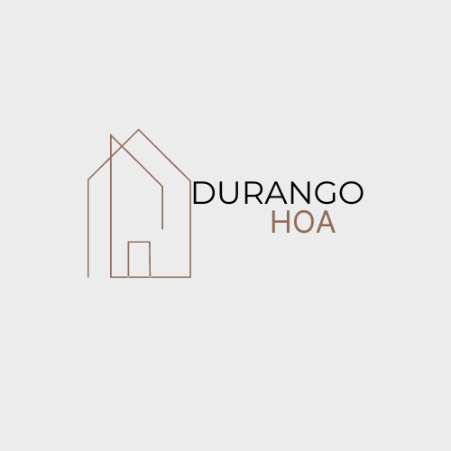Durango HOA Meeting Notes:

I. Introduction

A. Date and Time: March 3rd @2PM

B. Attendance: 9 community members, President Kat McManus, Treasurer Stephanie Martin, and Architectural Team Linda and Mike McClelland present

II. Review of Previous Meeting

A. Acceptance of meeting notes from 2023

B. Discussion on old business, focusing on budget reports and expenses

III. Financial Report

A. Explanation of surplus funds due to weather conditions and community efforts

B. Updates on expenditure, including tree trimming, picnic table repairs, and insurance policy changes

IV. Architectural Team Update

A. Discussion on violations during spring cleanup and their resolution

B. Appreciation for community efforts in maintaining the neighborhood's appearance

C. Preparation for upcoming spring cleanup and adherence to HOA regulations

V. Community Improvements

A. Focus on green space maintenance and preparation for sprinkler repairs

B. Proposal for permanent shelter, tree planting, and open play areas

C. Research and planning for proposed improvements, to be presented at 2025 meeting for voting  
 Vote: 9-0 in favor of researching possibilities for community improvements

VI. Neighborhood Concerns

A. Addressing speeding issues on 22nd street

B. Implementation of speed monitors and communication with council members

C. Votes on various community services and regulations

1. Vote: 9-0 in favor of Blue Mountains Lawn services

2. Vote: 9-0 in favor of community fertilizing green space

3. Vote: 9-0 in favor of adding "No Dog Poop" signs to park

4. Vote on lawn mowing fees: 8-1 in favor of implementing new fees  
 Vote on lawn mowing fees:  
*a. Proposal for new fees due to lawn maintenance issues and rental property standards  
i. 1st warning: 1-week notice to mow lawn*

*ii. 2nd warning: $25.00 fee with 1-week resolution*

*iii. 3rd warning: $50.00 fee with 1-week resolution*

*iv. 4th warning: Service fee for lawn mowed by HOA*

*b. Vote tally: 8-1 in favor of implementing new fees*

*- Note: These fees are cumulative and serve to maintain neighborhood standards and aesthetics.*

VII. Goals and Outreach for 2024

A. Emphasis on neighborhood cleanliness and upcoming trash pickup day

B. Compliance with Colorado regulations on fireworks and parking regulations in no parking zones

C. Safety reminders for school bus stops and increased neighborhood activity during summer

D. Handling dog barking complaints through NOCO Humane Society, NOT THE HOA

E. Announcement of Fall Community Festival plans in the greenspace. NO COMMUNITY PICNIC

VIII. Conclusion

A. Appreciation for community participation

B. Forward-looking to a successful 2024